Date : 20-10-2022 Saravanan.R

CH.EN.U4CYS21074

**20CYS204 – Database Management Systems**

**Lab – UML**

1. **Class Diagram for Library Management System.**

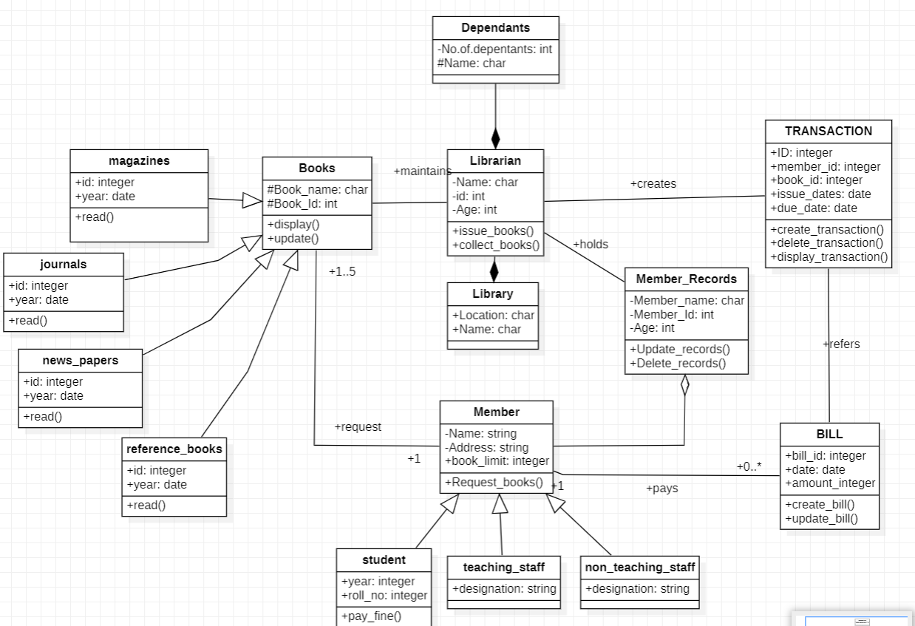

1. **Use case diagram for Airline Reservation System.**

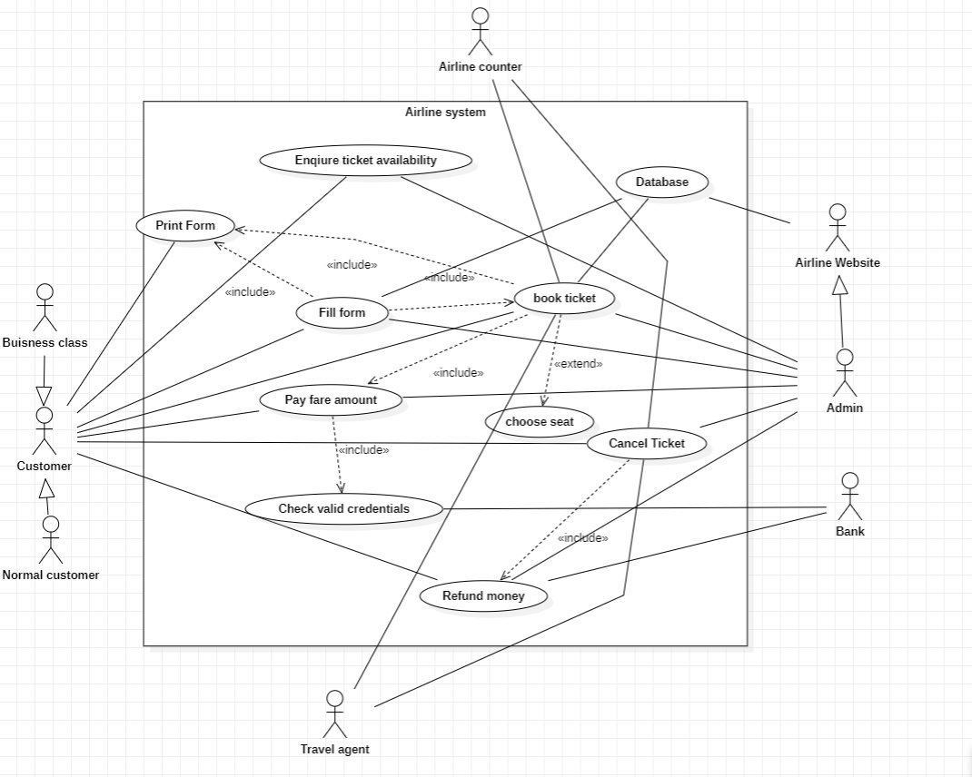

1. **Activity Diagram for ATM**

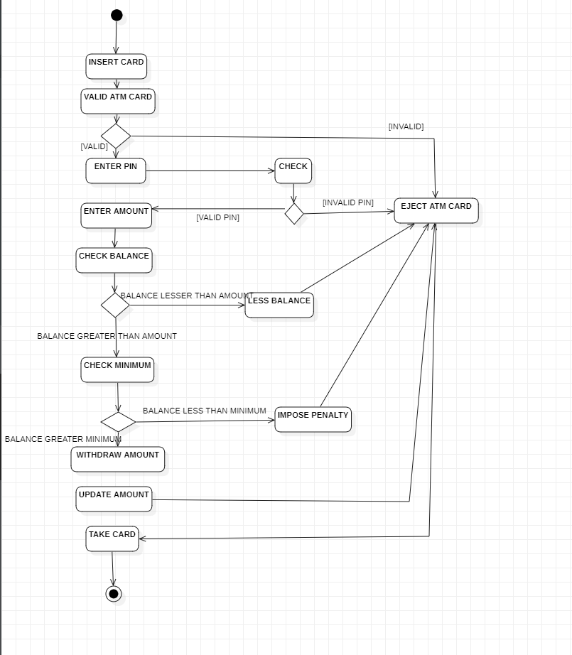

1. **Deployment diagram for Bank management System.**

